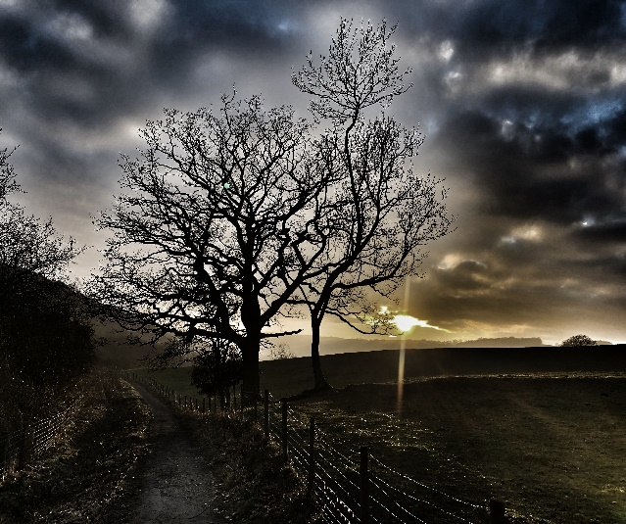
2021 Zoom Conference
The McCluskey Model for
Exploring the Dynamics of Attachment in Adult Life

8th & 9th May and 15th & 16th May 2021

£235.00

A £50 deposit is required on acceptance in order to secure your place on the Conference.
The remainder of the fee will be collected in April 2021

_________________________________________________________________________________________________________

NAME:

PROFESSION:

MEMBERSHIP OF PROFESSIONAL ORGANISATION (if any)

QUALIFICATIONS:

LENGTH OF TIME QUALIFIED:

ADDRESS:

CONTACT NO: EMAIL:

CURRENT WORK SITUATION, ROLE AND RESPONSIBILITIES:

NUMBER OF COURSES PREVIOUSLY ATTENDED WITH UNA McCLUSKEY (if any):

If you are new to the work, where did you hear about the Conference?

The experiential aspect of the Conference can be stressful. Have you got personal or professional support in your life at the moment YES/NO* (delete as appropriate).

In line with the requirements of GDPR, do you consent to us holding your details on our database so that we can inform you of future courses, workshops and Conferences Yes/No**

Please complete and return your application to info@unamccluskey.com. Alternatively applications can be printed and posted to:

Dr Una McCluskey
Wold Farm, Kilnwick Percy, YORK YO42 1SN UK

Conference places will be allocated on a first come, first served basis

_________________________________________

