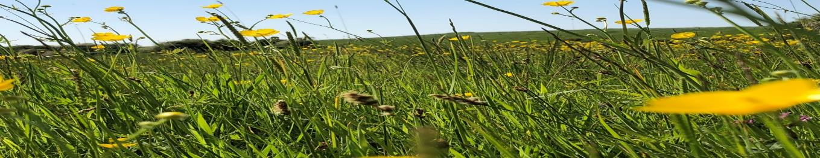

9th INTERNATIONAL CONFERENCE (RESIDENTIAL)
EXPLORATORY GOAL CORRECTED PSYCHOTHERAPY (EGCP)™

Dromantine Retreat & Conference Centre, Newry, Co Down, Northern Ireland

Monday 13th May 2019 – 17th May 2019

£725.00
(this breaks down as £385.00 for participation in the Conference and £340.00 for all-inclusive residential accommodation)

A £150 deposit is required on acceptance in order to secure your place on the Conference. A further £235 is payable at the beginning of February 2019 and the remaining £340 will be payable in early April 2019

APPLICATION FORM

NAME:

PROFESSION:

MEMBERSHIP OF PROFESSIONAL ORGANISATION (if any)

QUALIFICATIONS:

LENGTH OF TIME QUALIFIED:

ADDRESS:

CONTACT NO: EMAIL:

CURRENT WORK SITUATION, ROLE AND RESPONSIBILITIES:

NUMBER OF COURSES PREVIOUSLY ATTENDED WITH UNA McCLUSKEY (if any):

If you are new to the work, where did you hear about the Conference?

The experiential aspect of the Conference can be stressful. Have you got personal or professional support in your life at the moment YES/NO* (delete as appropriate).

In line with the requirements of GDPR, do you consent to us holding your details on our database so that we can inform you of future courses, workshops and Conferences Yes/No**

A light supper will be provided on Sunday 12th May at 6.30 pm. Attending the supper is a great opportunity to meet other Conference delegates. Please let us know if you will arrive in time for supper. As an alternative, a meal will be plated up for those arriving after 6.30 pm.

Accommodation requirements (please put a cross in the relevant box)

Name:

Subject to availability, please book me a single room

Subject to availability, please book me a double room

I will arrive on Sunday evening in time for the light supper

I will arrive on Sunday evening but not until after supper

I will arrive on Monday morning

I will leave Dromantine Retreat & Conference Centre on …………………………………….

For those of you arriving earlier than Sunday 12th or leaving later than Friday 17th accommodation rooms are available. Please request these below

Please book me extra accommodation on …………………………………. (at a cost of £68.00 per night).
This will include an evening meal and breakfast the following morning

Dietary requirements and/or allergies (if any):

Please complete and return your application to info@unamccluskey.com. Alternatively applications can be printed and posted to:

Dr Una McCluskey
Wold Farm
Kilnwick Percy
YORK
YO42 1SN
UK

Conference places and accommodation rooms will be allocated on a first come, first served basis

