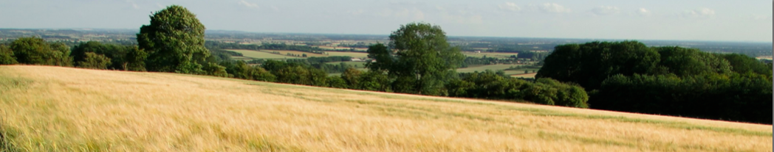

8TH INTERNATIONAL CONFERENCE (RESIDENTIAL)
EXPLORATORY GOAL CORRECTED PSYCHOTHERAPY (EGCP)™

Dromantine Retreat & Conference Centre, Newry, Co Down, Northern Ireland
http://www.dromantineconference.com/

Monday 8th May 2017 – Friday 12th May 2017

£700.00
(this breaks down as £375.00 for participation in the Conference and £325.00 for all-inclusive residential accommodation)

A £50 deposit is required on acceptance in order to secure your place on the Conference. A further £325 is payable by the 1st April 2017 and the remaining £325 will be payable by the 1st May 2017

APPLICATION FORM

NAME:

PROFESSION:

MEMBERSHIP OF PROFESSIONAL ORGANISATION (if any)

QUALIFICATIONS:

LENGTH OF TIME QUALIFIED:

ADDRESS:

CONTACT NO: EMAIL:

CURRENT WORK SITUATION, ROLE AND RESPONSIBILITIES:

NUMBER OF COURSES PREVIOUSLY ATTENDED WITH UNA McCLUSKEY (if any):

If you are new to the work, where did you hear about the Conference?

The experiential aspect of the Conference can be stressful. Have you got personal or professional support in your life at the moment YES/NO* (delete as appropriate).

A light supper will be provided on Sunday 7th May at 6.30 pm. Attending the supper is a great opportunity to meet other Conference delegates. Please let us know if you will arrive in time for supper. As an alternative, a meal will be plated up for those who arrive after 6.30 pm.

Accommodation requirements (please put a cross in the relevant box)

Name:

Subject to availability, please book me a single room

Subject to availability, please book me a double room

I will arrive on Sunday evening in time for the light supper

I will arrive on Sunday evening but not until after supper

I will arrive on Monday morning

For those of you who have return flights booked on Saturday 13th May

Please book me an extra night on Friday 12th May at a cost of £65.00.

This will include an evening meal and breakfast on Saturday

Dietary requirements and/or allergies (if any):

Please complete and return your application to info@unamcclusky.com. Alternatively applications can be printed and posted to:

Dr Una McCluskey
Wold Farm
Kilnwick Percy
YORK
YO42 1SN
UK

Conference places and accommodation rooms will be allocated on a first come, first served basis

